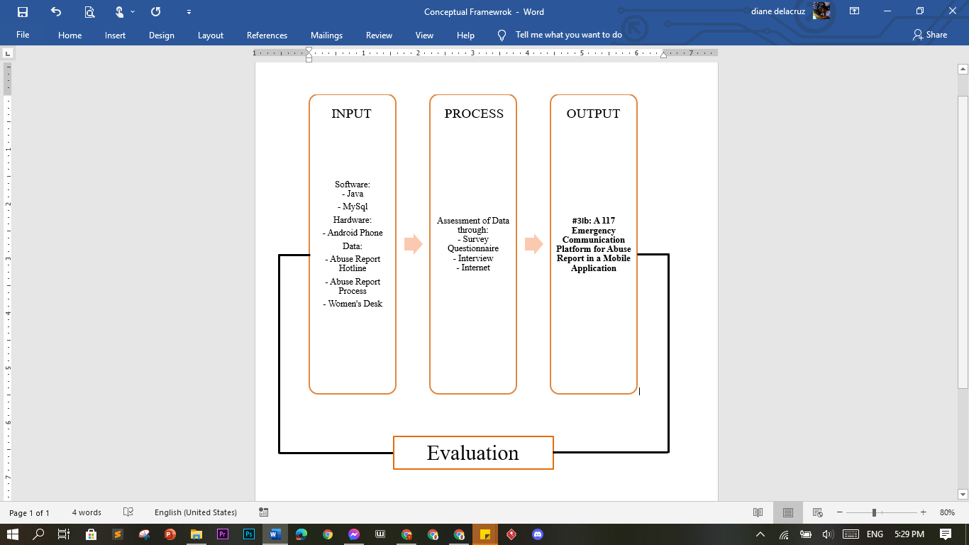

A conceptual framework explains why a certain study should be carried out. The conceptual framework establishes the methodological underpinnings of the research endeavor and describes the state of known information (Varpio et al., 2020). The conceptual framework is made up of input-process-output. The proposed system's Conceptual Framework will demonstrate how the study will be conceived and realized.

As stated in the diagram above shown by the proponents, the inputs are as follows; Software, hardware and Data. The software that will be used to develop the application are Java, Mysql and Android Studio. The hardware that will be used are Android Phone and Laptop. The Data that will be used to provide information to the application came from the information gathered from the interview of police officers and website. In the process phase, the system will process the data gathered from pre-survey questionnaires, interviews and related studies from the internet. With the help of the inputs and processes the mobile application will be developed. The proponents and end users will test the system to see if it works properly, and if bugs or errors are discovered, the developers will troubleshoot the issue, and once it has been resolved, the developers will test the system again to see if there are any remaining issues or if the system is working properly.